Retinal Imaging Consent Form
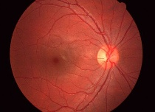
Healthy Eye: Diseased Eye:
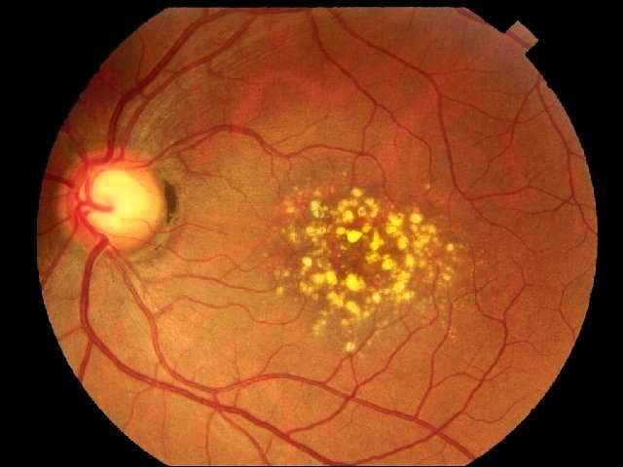

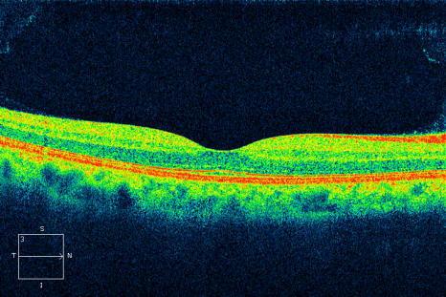
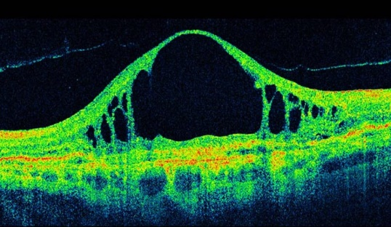

As part of your eye exam our office recommends an advanced diagnostic procedure called Retinal Imaging with OCT. This procedure consists of capturing an image of the back of your eye (the retina). This image is a valuable tool in the early diagnosis of such diseases as Macular Degeneration, Glaucoma, and Diabetic Retinopathy. The images enable your doctor to see and evaluate the surface of the retina, as well as underlying tissue that cannot be viewed directly during your annual eye exam.
This information is valuable in assessing the current health of your eye and for safeguarding the health of specific structures of your eye, such as the retina, optic nerve, macula, and blood vessels. It will also serve as a baseline from which to compare in the future.
The fee for this part of the eye exam is $39.00. Under most circumstances, retinal images are not covered under most vision plans, including medical insurance or Medicare. The office will advise you if you have a diagnosis in which coverage may apply in the future. You may be required to submit a receipt for reimbursement from your insurance provider.

___ Yes, I want to have retinal images taken of my eye for documentation.
___ No, I do not wish to have retinal images taken.

